标题字体



简介字体



CITYSCAPES(模板一)

1)Champs de Mars

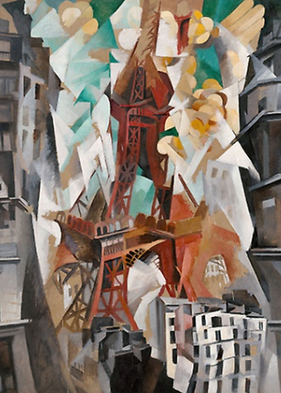

Champs de Mars: The Red Tower Date:

1911/23

Artist:

Robert Delaunay

French, 1885–1941

2）The Shelton with Sunspots, N.Y.

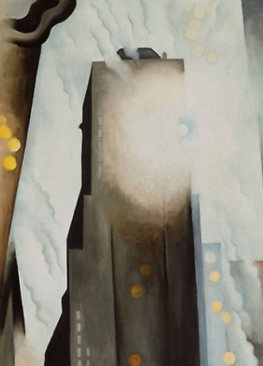

The Shelton with Sunspots, N.Y. Date:

1926

Artist:

Georgia O'Keeffe

American, 1887–1986

1. The Home of the Brave

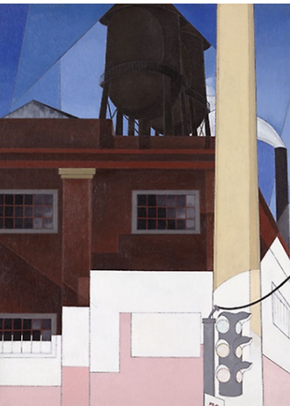

The Home of the Brave Date:

1931

Artist:

Charles Demuth

American, 1883–1935IMPRESIONISM

ANIMALS(模板二)

1) Boy on a Ram

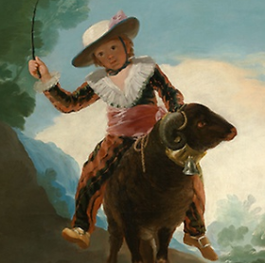

Boy on a Ram Date:

1786/87

Artist:

Francisco José de Goya y Lucientes

Spanish, 1746–1828

2) The Combat of the Giaour and Hassan

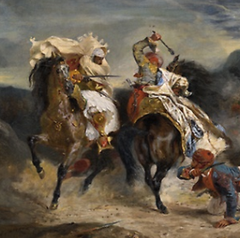

The Combat of the Giaour and Hassan Date:

1826

Artist:

Eugène Delacroix

French, 1798-1863

3) The Policeman

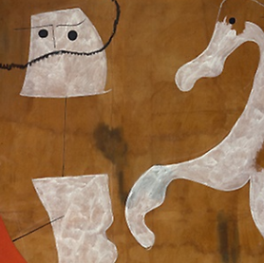

The Policeman Date:

1925

Artist:

Joan Miró

Spanish, 1893–1983

4) The Advance-Guard

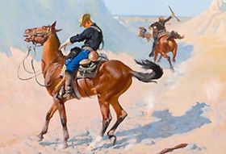

The Advance-Guard Date:

1890

Artist:

Frederic Remington

American, 1861–1909

5) Cat Making Up

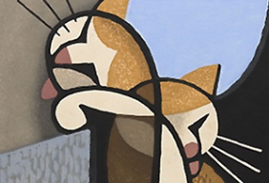

Cat Making Up Date:

1962

Artist:

Inagaki Tomoo

Japanese, 1902–1980

6) Homage to Tamara Toumanova

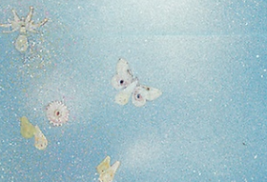

Homage to Tamara Toumanova Date:

December 1940

Artist:

Joseph Cornell

American, 1903-1972

ESSENTIALS（模板一）

1）Time Transfixed

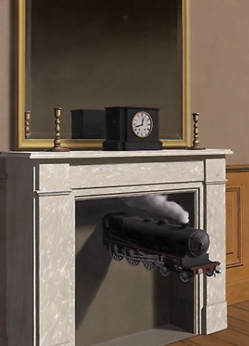

Time Transfixed Date:

1938

Artist:

René Magritte

Belgian, 1898–1967

2）The Fountain, Villa Torlonia, Frascati, Italy

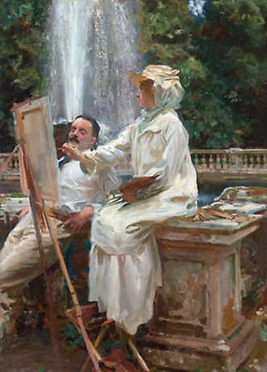

The Fountain, Villa Torlonia, Frascati, Italy Date:

1907

Artist:

John Singer Sargent

American, 1856–1925

3）Saint George and the Dragon

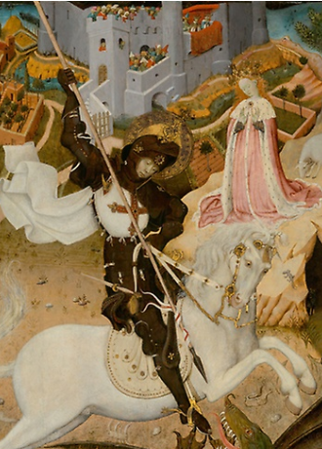

Saint George and the Dragon Date:

1434/35

Artist:

Bernat Martorell

Spanish, about 1400–1452

FASHION（模板二）

1）Love of Winter

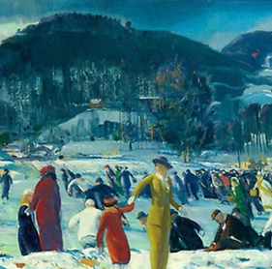

Love of Winter Date:

1914

Artist:

George Wesley Bellows

American, 1882–1925

2）Spanish Dance

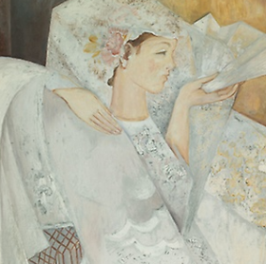

Spanish Dancer Date:

1920s

Artist:

Natalia Goncharova

Russian, 1881–1962

3）Portrait of Arthur Jerome Eddy

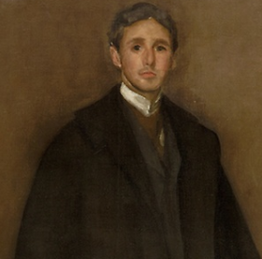

Portrait of Arthur Jerome Eddy Date:

1894

Artist:

James McNeill Whistler

American, 1834–1903

4）Woman's Robe



Woman's Robe Date:

1840s/60s

Artist:

Uzbekistan, Bukhara

5）Cravat End

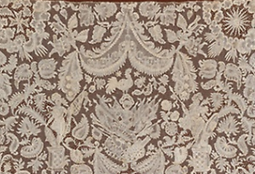

Cravat End Date:

1700/40

Artist:

Belgium, Flanders, Brussels

6）Mohnköpfe

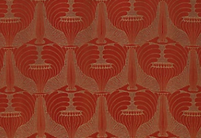

Mohnköpfe Date:

1900

Artist:

Designed by Koloman Moser (Austrian, 1868–1918)

Produced by Johan Backhausen und Söhne Austria, Vienna

POP ART（模板一）

1) Little Race Riot

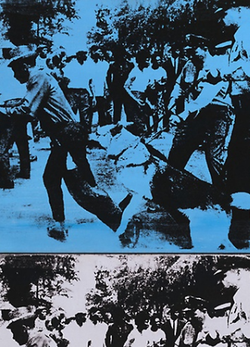

Little Race Riot Date:

1964

Artist:

Andy Warhol

American, 1928–1987

2) Fagend Studies

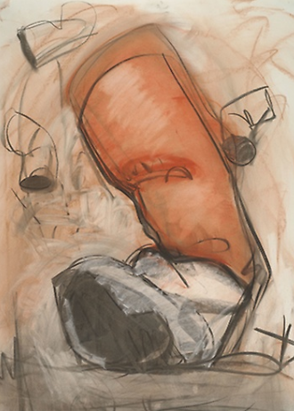

Fagend Studies Date:

1976

Artist:

Claes Oldenburg

American, born Sweden, 1929

3) Landscapes 8

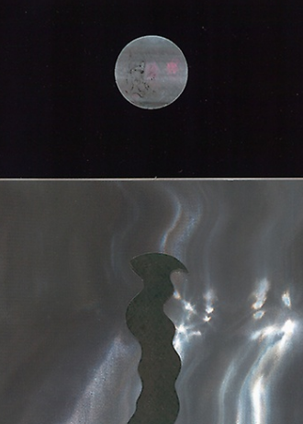

Landscapes 8 Date:

1967

Artist:

Roy Lichtenstein (American, 1923-1997)

printed by Charles Cardinale at Fine Creations, Inc.

MODERNISM(模板二)

1）White Crucifixion

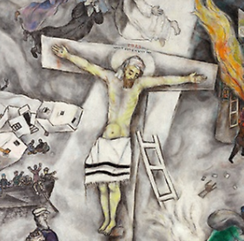

White Crucifixion Date:

1938

Artist:

Marc Chagall

French, born Vitebsk, Russia (present-day Belarus), 1887–1985

2）Improvisation No. 30

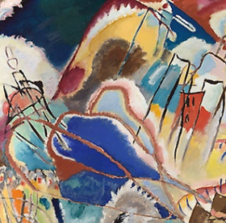

Improvisation No. 30 Date:

1913

Artist:

Vasily Kandinsky

French, born Russia, 1866–1944

3）The Earth Is a Man

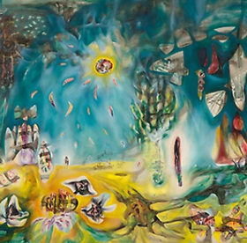

The Earth Is a Man Date:

1942

Artist:

Roberto Matta

Chilean, 1911–2002

4）Nocturne

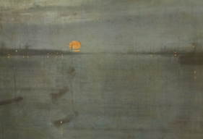

Nocturne Date:

1872

Artist:

James McNeill Whistler

American, 1834–1903

5）Croquet Scene

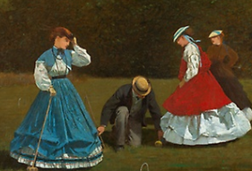

Croquet Scene Date:

1866

Artist:

Winslow Homer

American, 1836–1910

6）Train Station

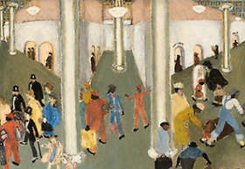

Train Station Date:

1935

Artist:

Walter Ellison

American, 1899–1977

WOODBLOCK PRINT（模板一）

1）A Tour of Waterfalls in Various Provinces

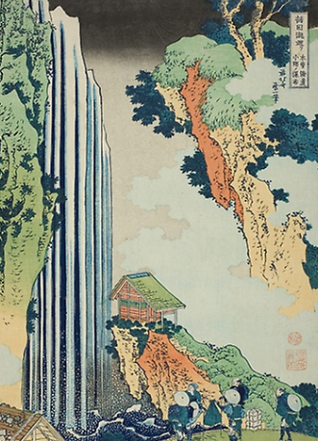

A Tour of Waterfalls in Various Provinces Date:

c. 1833

Artist:

Katsushika Hokusai 葛飾 北斎

Japanese, 1760-1849

2）Takashima Ohisa

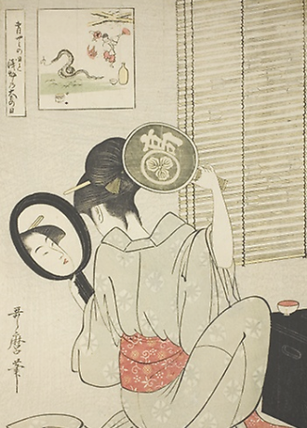

Takashima Ohisa Date:

c. 1795

Artist:

Kitagawa Utamaro 喜多川 歌麿

Japanese, 1753-1806

3）A Young Woman in a Summer Showe

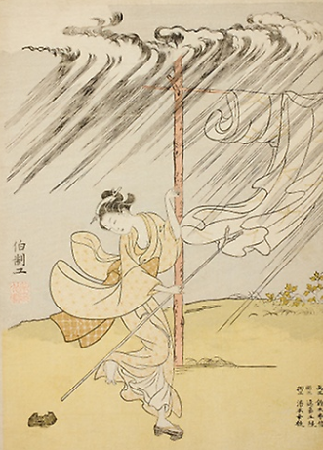

A Young Woman in a Summer Shower Date:

1765

Artist:

Suzuki Harunobu 鈴木 春信

Japanese, 1725-1770

CHICAGO（模板一）

1）Mrs. George Swinton

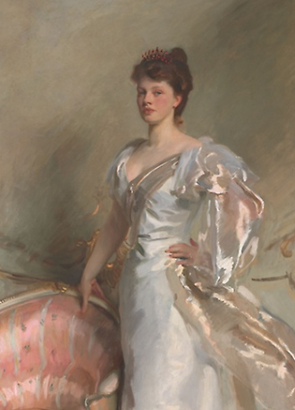

Mrs. George Swinton Date:

1897

Artist:

John Singer Sargent

American, 1856–1925

2）Nouvart Dzeron

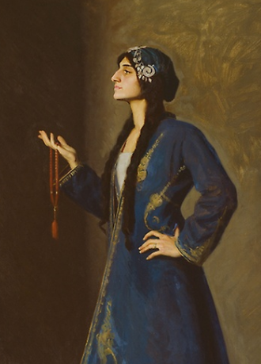

Nouvart Dzeron Date:

1912

Artist:

Ralph Elmer Clarkson

American, 1861–1942

3）The Coffee House

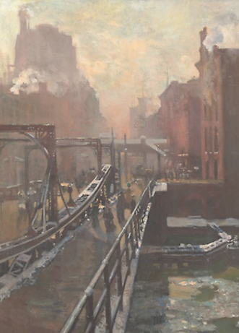

The Coffee House Date:

Winter 1905/6

Artist:

Alson Skinner Clark

American, 1876–1949

IMPRESIONISM（模板一）

1）Two Sisters

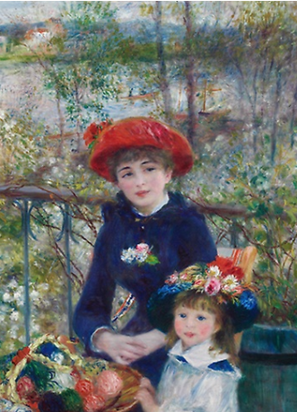

Two Sisters Date:

1881

Artist:

Pierre-Auguste Renoir

French, 1841-1919

2）At Mouquin's

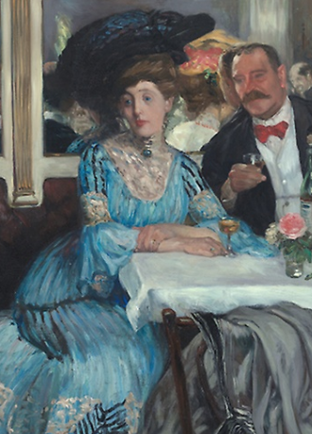

At Mouquin's Date:

1905

Artist:

William Glackens

American, 1870–1938

3）Woman at the Piano

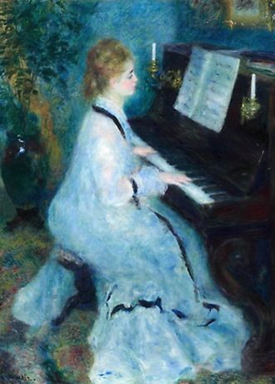

Woman at the Piano Date:

1875/76

Artist:

Pierre-Auguste Renoir

French, 1841-1919